Gabriel Rubin
Arthur F. Burns Fellowship Report—Placement at Der Tagesspiegel, Berlin
August and September 2018

I spent my time as an Arthur Burns Fellow working in the business section of Der Tagesspiegel in Berlin. It became clear shortly after I started there that I would be most helpful to them by writing about U.S. economic issues, especially given ongoing trade tensions between the United States and China, Mexico, Canada, and other countries. While Der Tagesspiegel has a Washington correspondent, she is tasked with nearly all news coming out of the US-- no easy task under the calmest of circumstances, but one that is laughably impossible during the Trump era.
My Tagesspiegel editors told me before I left that while they had had Burns fellows working in the business section before, I was the first reporter who actually reports on economic issues in the US-- the others had been political reporters who just happened to be placed in the business section. They made good use of my subject knowledge-- I wrote three trade stories, all of which ran at the top of the front page of the business section. Some of the story ideas were solicited explicitly by editors, but other times they simply asked me what ideas I had related to trade and gladly accepted the story ideas I came up with. Timing also played a role, as it always does in the news business: my time at Tagesspiegel coincided with the tenth anniversary of the 2008 global financial crisis, and since I normally report on financial regulation, I wrote a piece detailing the build-up of the postcrisis regulatory regime and its subsequent partial dismantling by Congress and the Trump administration.
Not wanting to solely report on economic issues, I also wrote a story about the increasing interest in socialist ideas in the United States, told through an interview with Jacobin magazine editor and Democratic Socialists of America leader Bhaskar Sunkara. Sunkara happened to be visiting Berlin for a speaking engagement during the time of the fellowship. This piece was handled by the politics team, who I reached out to independently of my business-section editors. I was encouraged to pursue the story and, despite somewhat annoying publishing delays (this was not communicated to me at the time, but apparently they are planning on running it shortly before US elections in November), got positive feedback from Tagesspiegel reporters and editors as I worked on it.
Though I felt I had a productive stint at Tagesspiegel over all, I was certainly slightly hamstrung by my lack of German language skills. Tagesspiegel, like virtually every news organization everywhere, has seen a resource crunch in recent years, and editors told me very honestly that there were only so many of my stories they’d have time to translate. There were multiple occasions when both they and I thought I could write something newsy and illuminating about the day’s news, but we had to scrap the idea because it was too late in the day for an editor to have time to both translate and edit it before the print deadline crunch.
Still, I would recommend Tagesspiegel to future fellows. I found it to be a warm, welcoming professional environment with helpful former Burns fellows and serious journalists. I never lacked for someone to have lunch with and despite my language deficiency never felt like I was excluded from the office culture. As a point of contact there, I particularly recommend Kevin Hoffmann, who was extremely welcoming, flexible, and generous with his time. He made the point to me on my last day there that they would like business-focused reporters in the future, since I was able to hit the ground running and provide more value than a non-business focused reporter who just happened to be placed in that section.
With regard to my work for my home outlet, the Wall Street Journal, I will say that I do not believe I was able to take full advantage of my time in Germany. This wasn’t for lack of trying, nor do I blame WSJ editors-- I think I simply realized that parachuting into a country and immediately trying to be a foreign correspondent, when your publication already has about 30 people in the country, can be a risky proposition.
For the Journal, I put my eggs all in one basket. I brainstormed with the Berlin bureau chief on a pitch for an enterprise story about changing attitudes towards communist ideas among German youth who grew up after the fall of the Berlin Wall. The idea was a good one in theory, and my reporting bore the theory out-- but not in a newsy way. What I came up with was essentially an essay, not a news story, and not something the Wall Street Journal was going to publish as a news story. I spent several weeks doing the reporting for the story, interviewing numerous former East German dissidents, historians, and Die Linke members. But while I got interesting quotes and perspectives, I didn’t have a story about a self-conscious phenomenon. The Berlin bureau chief reluctantly but understandably pulled the plug on the story.
The experience of reporting that story was in no way a total loss. I learned an immense amount about German politics and historical memory, and if I had stayed longer, could probably have retooled that knowledge into a different kind of piece that might have been better for the WSJ. But I ran out of time.
Lastly, I understand that all fellows, but particularly those who were based in Berlin, have been asked to reflect on whether they chose their locations properly. I will say that knowing I had a support system of other fellows in Berlin was helpful, particularly given the language barrier. I do not think it hindered my ability to experience Germany on its own terms-- indeed, I made German friends and did not spend most of my time hanging out with other fellows. And Berlin as a city is, of course, an incredible place to spend two months. Having now visited other cities in Germany, however, I do think that I would have had an equally good experience in, say, Hamburg or Munich or Frankfurt, especially with my focus on business and trade. But I do not regret at all choosing to be in Berlin either.
Links to stories:

Schlechte Laune von Kansas bis Nord-Dakota
https://www.tagesspiegel.de/wirtschaft/trumps-neuste-strafzoelle-schlechte-laune-vonkansas-bis-nord-dakota/22933190.html
Nicht das letzte Wort
https://www.tagesspiegel.de/wirtschaft/trumps-handelspolitik-nicht-das-letzte-wort/22968446.html
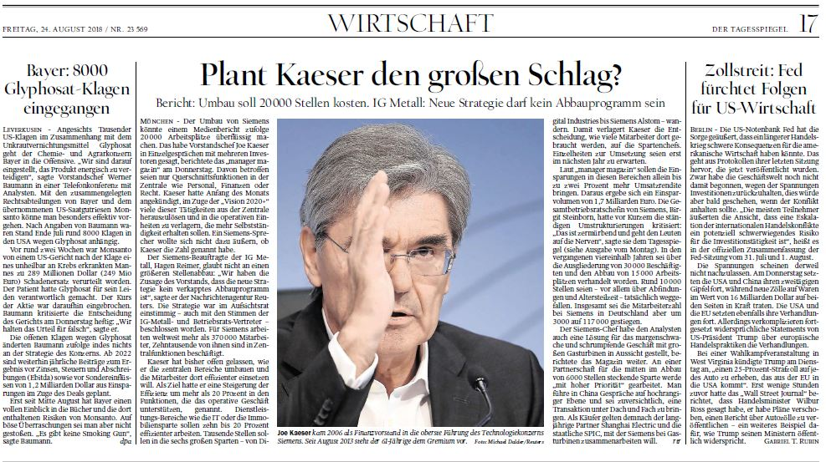
(The article on the right appeared in print but not online)
Wie Trump die Banken-Regeln zurückdreht
https://www.tagesspiegel.de/wirtschaft/finanzkrise-wie-trump-die-banken-regeln-zurueckdreht/23013312.html

Manuscript of piece to run before the US elections in November:
U.S. Socialists Gain Confidence With Series of Election Wins
Gabriel T. Rubin
Multiple socialist candidates are expected to be elected to the US Congress this year. Senator Bernie Sanders, the most well-known socialist in American politics, appears to be preparing for another run at the presidency. And establishment Democrats including former President Barack Obama have endorsed ideas that used to be dismissed as utopian extremism, like universal healthcare.
American socialists are seemingly scoring win after win. But Bhaskar Sunkara, a leader of the Democratic Socialists of America and founder of the popular socialist Jacobin Magazine, cautions that the hard work remains ahead, and that the Left must not miss its current opportunity to transform the Democratic Party and expand the American welfare state.
“There’s a pull in the Democratic Party now towards more socialist politics that has more teeth than usual,” Sunkara said in an interview with Der Tagesspiegel during a visit to Berlin for an event promoting the comeback of socialism in the US. “But without coherent leadership and without coherent structures, these movements can’t accomplish their goals and they become simply media events.”
Sanders’ 2016 campaign, though unsuccessful, brought socialist ideas to the forefront of American politics for the first time in decades. He won 13.2 million votes and 23 states and territories, vastly exceeding expectations. In defeat, he pushed Hillary Clinton to adopt some of his policies, including support for debt-free college tuition at public universities.
But Clinton’s defeat to Donald Trump made many Democrats and others on the left question whether a more populist campaign would have been able to defeat Trump. In the two years since Trump’s election, a surge in voter engagement on the left has led to notable victories for candidates who either identify as socialists or who support the policies that Sanders campaigned on, including raising the minimum wage to $15, universal healthcare, and abolishing the U.S. Immigration and Customs Enforcement agency, which many on the left see as an unchecked police force carrying out Trump’s draconian immigration policies with impunity.
The most publicized victory for socialists came in June, when Alexandria Ocasio-Cortez, a 28-year-old former bartender from the Bronx, defeated a top congressional Democrat in a primary election. Her election came as a shock to the Democratic establishment and immediately positioned her as a new force in the party, garnering extensive media attention and traveling to other districts to support insurgent candidates. Ocasio-Cortez was an organizer for Sanders’ presidential campaign and a dues-paying member of the Democratic Socialists of America.
DSA now has over 50,000 dues-paying members, roughly doubling its size since Trump’s win. Another DSA member, Rashida Tlaib, won her Democratic primary for a congressional seat in Michigan and is expected to be elected in the November general election.
Leaders like Sanders and Ocasio-Cortez are the faces of socialism in America, and Sunkara says their charisma is key to socialism’s near-term electoral success.
“Every movement needs a charismatic politician. Bernie represents the invigoration of the base,” he said.
What worries Sunkara is that a future Democratic presidential candidate with ties to both the Democratic establishment and to the left-wing of the party will be able to co-opt the socialist message while weakening it overall to make it palatable to a larger audience.
He’s especially concerned that someone like Senator Elizabeth Warren, a popular senator from Massachusetts who remained neutral in the 2016 Democratic primary and is well-liked by both Clinton and Sanders supporters, will manage to slow the leftward movement of the party by trying to satisfy too many constituencies.
“Warren could be someone who waters down the anger and enthusiasm we saw during the Bernie campaign into a series of policy points,” he said. “And the policy points over time will become something that’s palatable to most business interests, and that’s a huge threat.”
For Sunkara, there’s just one option when it comes to the 2020 presidential election.
“It’s either Bernie or nothing in 2020, that’s how I see it.”

